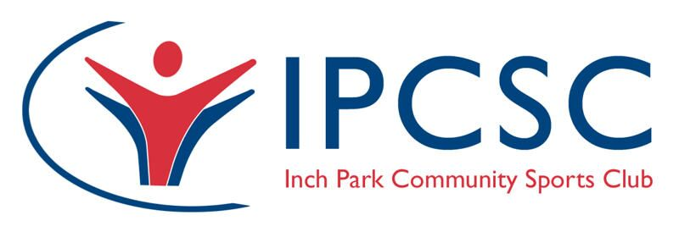

Coaching Leadership Programme

Applicant Contact Information
Full Name:
Address:
Date of Birth: |  | Contact Number:

Email Address:

Equal Opportunities
As part of our funding, priority will be given to individuals who consider themselves to meet one or more of the following characteristics. Please note, you do not have to declare anything you are not comfortable with. Priority will be given to those that declare these characteristics. If you do not wish to declare you are still encouraged to apply. Please tick all that apply.

☐ | Low income individual or household (http://www.poverty.org.uk/s01/index.shtml) | ☐ | Mental Health condition (inc. depression, anxiety) | ☒ | Disabled
☐ | Long standing illness or condition | ☐ | Affected by abuse | ☒ | Primary carer

☐ | Aged 65+ | ☐ | Aged 17 - 25 |  | Primary carer

☐ | LGBTI | ☐ | Offender / Ex-Offender | ☐ | At risk of, or experience of homelessness

☐ | Recovering from addiction | ☐ | Single Parent | ☐ | Black, minority or ethnic group

Club Information
Hosting Club:
Address:
Main Club Contact (and position at club): |  | Contact Number:

Email Address:

Declaration
I have read and understood the commitments required of me in order to be eligible for the programme. They are as follows:
- You are able to commit to coaching at a club as a volunteer for the summer of 2018 following completion of the programme in March 2018 (please note this can be a mix of paid and voluntary work, but MUST involve some form of voluntary commitment.
- You are willing to commit to seven Sundays between October and February in Edinburgh to take part in the course.
- That you are able to complete all the learning and assessment involved in the L2 coaching badges by the end of March 2018.

Applicant signature:
Applicant name:
Date:

Supporting club signature:
Name and position:
Date:

Final Checklist

This application form must be completed in full, signed and support by two cover letters – one from the applicant and one from the hosting club. The individual cover letter must include:
- Your motivation for applying
- Confirmation you understand the commitment involved to both the course and your host club, and are willing to commit what is required
The club cover letter must include:

- Confirmation of the role the individual will play at the club following the course (including specifics of role, approximate hours and whether paid or voluntary and split if both)
- The impact this is expected to have on the club over a three year period

Completed and signed applications must be received by 5pm on Friday 8th September 2017. They can either be emailed to reddishpaul@yahoo.co.uk or sent via post to:

Paul Reddish, Inch Park Community Sports Club, 59 Greenbank Crescent, Edinburgh. EH10 5TD.

If applications are sent in the post, notification must also be provided via email or text. Confirmation of receipt of applications will be sent within 48 hours.

If you wish to discuss any aspects of the programme or application, please contact Paul Reddish (reddishpaul@yahoo.co.uk) or 07585 048414.

