PVG SCHEME - GUIDE TO THE APPLICATION PROCESS

The following process should be followed by clubs, employees and volunteers who intend undertaking regulated work with children. Following this process will allow applications to be dealt with in an appropriate timescale and avoid undue delays caused by errors. Clubs must not rely solely on the PVG Scheme as the only check of an applicant’s suitability to work with children. The Club must carry out additional checks including references, interview and induction.

Self Declaration Form |  |  | 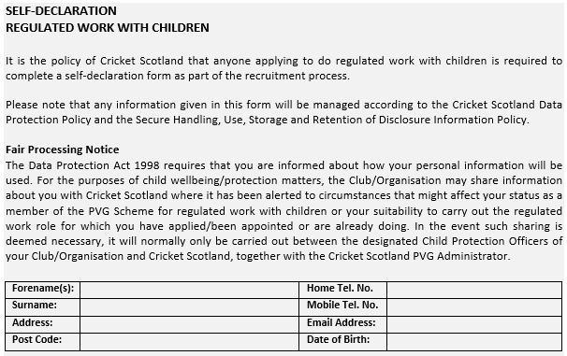
The applicant completes the Self Declaration form (obtained from the Club CWPO). The form is returned to the Club CWPO. As this form contains personal data, it is recommended that the form be handed personally or left in a sealed envelope cleared addressed to the Club CWPO.
The Self Declaration Form is retained for record purposes by the Club CWPO.
Within the Form the applicant will have indicated if they are currently a member of the PVG Scheme which will determine which Disclosure Scotland application form they will be issued with or directed to by the Club CWPO.

New Applicants to the PVG Scheme |  |  |  | Existing PVG Scheme Members
The Club CWPO will issue or direct the applicant to the Disclosure Scotland form “Application to Join the PVG Scheme”. Applicants should also be issued with guidance notes for the completion of the form. Club CWPO’s will hold sample completed forms to further assist correct completion.  The applicant will return the completed form to the Club CWPO together with three forms of identification. The types of acceptable identification are outlined on the Confirmation of Identity form. Club CWPO’s will complete this form.  There is no requirement to take copies of the ID provided.  After checking it, the Club CWPO will forward the completed application form and Confirmation of Identity form to the PVG Administrator at Cricket Scotland on disclosures@cricketscotland.com  New Member PVG Form (online) |  |  | The Club CWPO will issue or direct the applicant to the Disclosure Scotland form “Existing PVG Scheme Member Application”. Applicants should also be issued with guidance notes for the completion of the form. Club CWPO’s will hold sample completed forms to further assist correct completion.  The applicant will return the completed form to the Club CWPO together with three forms of identification. The types of acceptable identification are outlined on the Confirmation of Identity form. Club CWPO’s will complete this form.  There is no requirement to take copies of the ID provided.  After checking it, the Club CWPO will forward the completed application form and Confirmation of Identity form to the PVG Administrator at Cricket Scotland on disclosures@cricketscotland.com.  Existing Member PVG Form (Online)

PVG Administrator
The PVG Administrator will check application forms and complete the sections in relation to the Registered Body: Countersignatory Details and Declaration. The application will then be forwarded to Disclosure Scotland.

Result
There are three possible outcomes from an application to join the PVG Scheme or a request for a PVG Scheme Record Update.
● The applicant is on the “Barred from Working With Children’s List”. PVG Scheme membership will be refused. The PVG Administrator will inform the Club of this decision and confirm that the applicant cannot undertake regulated work with children.
● The applicant is granted membership of the PVG Scheme. A certificate of membership is issued directly to the applicant. Cricket Scotland also receive a copy certificate. The PVG Administrator will email the result to the Club CWPO together with the PVG membership number and date of issue. Cricket Scotland will then destroy the copy certificate.
● The applicant is granted membership of the PVG Scheme but there are previous convictions or vetting Information that requires discussion between the Club and Cricket Scotland as to the suitability of the applicant undertaking regulated work with children. Discussion will normally be limited to the Club CWPO, the PVG Administrator and the Cricket Scotland Lead CWPO.
The final decision regarding the applicant undertaking regulated work with children will be made by the Club.

Recording
The Club CWPO will keep updated records of PVG Scheme membership on the PVG Control Sheet.

