Non-protected
Wellbeing survey questions

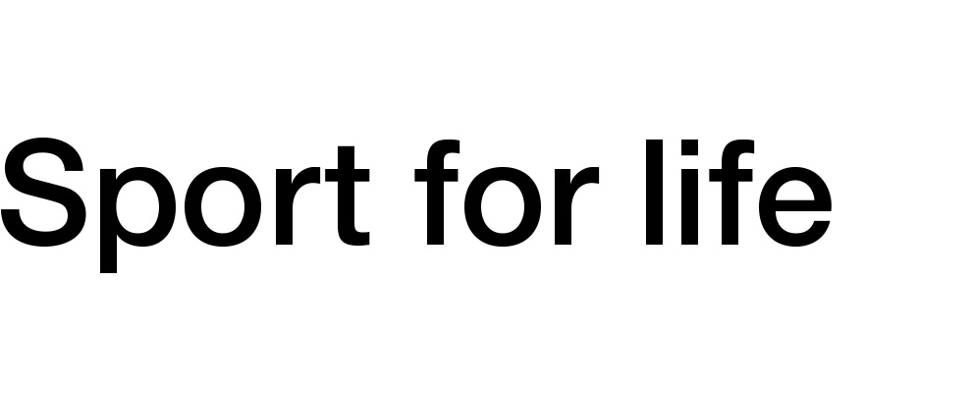
The purpose of this survey is to help Cricket Scotland to understand your needs during these difficult times. We will not follow-up with respondents, and so if you are struggling with your mental health, please reach out to a mental health professional.
NHS online helpline
Information you provide in response to this survey will be processed in accordance with Data Protection legislation. Your responses will always be anonymised in any reports we generate from the data provided. We will not pass participant data on to any third parties.

SECTION 1: Demographic Questions

Q1. What is your gender?
Q2. What is your age?

SECTION 2: During lockdown

Q.3 My sleep quality has: significantly worsened / somewhat worsened / stayed about the same as normal / somewhat improved, significantly improved
Q.4 My self-care strategies have: been much harder to implement / been somewhat harder to implement / continued as normal / been easier to implement / been much easier to implement
Q.5 My connection with others has: significantly decreased / somewhat decreased / stayed about the same as normal / somewhat increased, significantly increased
Q.6 My relationships with my family have: significantly worsened / somewhat worsened / stayed about the same as normal / somewhat improved, significantly improved
Q.7 My mood has generally: significantly worsened / somewhat worsened / stayed about the same as normal / somewhat improved, significantly improved
Q.8 my activity level has: significantly decreased / somewhat decreased / stayed about the same as normal / somewhat increased, significantly increased
Q.9 My connection with nature has: significantly decreased / somewhat decreased / stayed about the same as normal / somewhat increased, significantly increased

Q.10 My mental health and wellbeing has: significantly worsened / somewhat worsened / stayed about the same as normal / somewhat improved, significantly improved

SECTION 3: Emerging from lockdown

Q.11 When you think about the return from lockdown, is there anything that makes you nervous or worried? (If so, please state)
Q.12 What do you most miss from your sport?
Q.13 What do you think would help your mental health and wellbeing in the coming months?
Q.14 Is there anything else you would like us to know about how we can support you?

NOTE: Depending on how short you want to keep the survey, you could also add the following 5 questions to get a wellbeing baseline.

SECTION 4: General Wellbeing

Q.15 On a scale of 0-10, where 0 is not at all satisfied and 10 is completely satisfied, overall, how satisfied are you with your life nowadays?
Q.16 On a scale of 0-10, where 0 is not at all happy and 10 is completely happy, overall, how happy did you feel yesterday?
Q.17 On a scale of 0-10, where 0 is not at all anxious and 10 is completely anxious, overall, how anxious did you feel yesterday?
Q.18 On a scale of 0-10, where 0 is not at all worthwhile and 10 is completely worthwhile, overall, to what extent do you feel the things you do in your life are worthwhile?
Q.19 To what extent do you agree with the statement ‘I can achieve most of the goals I set myself‘? Strongly Disagree / Disagree / Neutral / Agree / Strongly Agree
Q.20 To what extent do you agree or disagree that most people in your sporting community can be trusted? Strongly Disagree / Disagree / Neutral / Agree / Strongly Agree

